How To Build a Release of Stars!Nova

1/ set Global.debug to False:
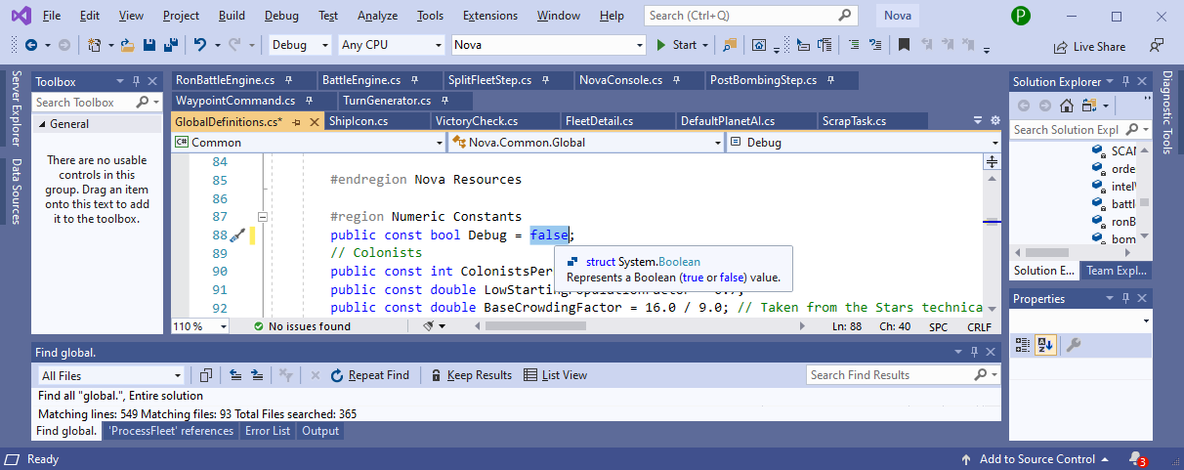
2/ if components.xml has changed update components.zip

3/ if DefaultRaces folder has changes update DefaultRaces.zip

4/ if files in the Graphics directory tree have changed update Graphics.zip

5/ Publish the project

